Survey / Interview Results

The Solar Thermal Heating Group consentrated our study on Upland Hills Ecological Center. On the initial site visit we met with Clifford Scholtz, the Education Coordinator. Cliff gave of us a tour of the site and intruduced us to many of their sustainable features, including a thermal mass rock wall, photovoltaic array, wind turbine, green roof, and thermal air collector-rock storage unit. Our group consentrated our studies on the thermal air collector-rock storage unit.
Some students also study the Taubman Builing on Lawrence Technological Unversity’s campus. This building is more modern compared to the UHEAC. I assisted in creating and analizing an occupant survey for this building. We asked questions pertaining to the comfort and maintenaince in the building.
The survey results revealed that there are many concerns of the occupants. Problems range from no natural ventalation to too much daylighting, uncomfortable drafts, noise problems, and shockingly possible health problems. From here other teams went ahead with testing at the Taubman Building.
Cliff voiced concerns about the effieciency of the center, since it is over 30 years old. Many of the systems introduced when first built are dated, even though the center has also done may upgrades through out the years. Many challenges arise as to keeping up with current technology.


Photo by Craig Necci

Analysis

Our group was somewhat split into other sub-groups, the air collector investigators, the rock storage investigators, and energy analysis investigators with some overlap between each team. The team I am involved with concentrated on the rock storage and energy analysis.
Initially the solar exposure was recorded to determine that the air collector panels do not achieve the maximum potential of sun exposure that could be possible. The trees that frame the south facing wall, where the panels are located, obstruct the winter sun from reaching the panels. This is when heat is most needed. The collectors slope at 58° to maximize the winter sun.

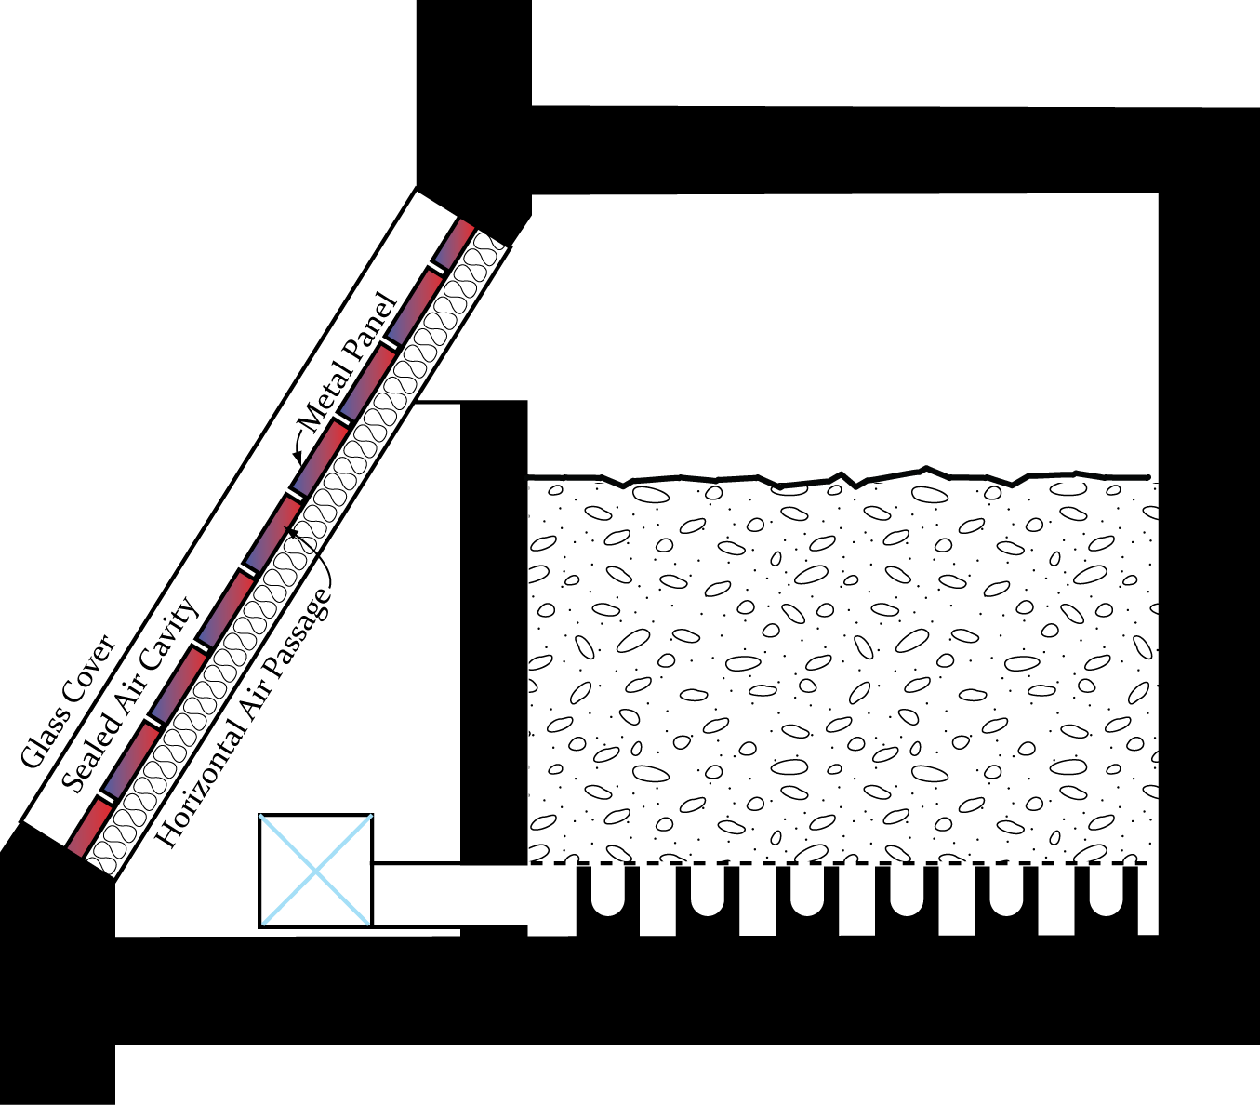

The diagram to the left represents the connection between the air collector panesl the rock storage bin. (Diagram provided by Ryan Grabow)
A problem we found within the solar panels is that they are not sealed properly. Air is getting infiltrated in and weeds are starting to grow between the glass panes.

While doing research on rock storage I found a case study that is somewhat closely related to our setup. The case study I refer to is the Burnside House-Seagroup (Levy, Evans, Gardstein, & Winter Ass 83, 64.) The rock storage system included in the Burnside example is located under the living spaces beneath the floor to the north. “During the day, warmed air rises in the sunspace and is circulated down and across the rock beds with the aid of induction fans. Air releases it heat to the rocks, which in turn warm the adjacent masonry surfaces. This heat slowly dissipates throughout the day and evening hours” (Levy, Evans, Gardstein, & Winter Ass 83, 64.)
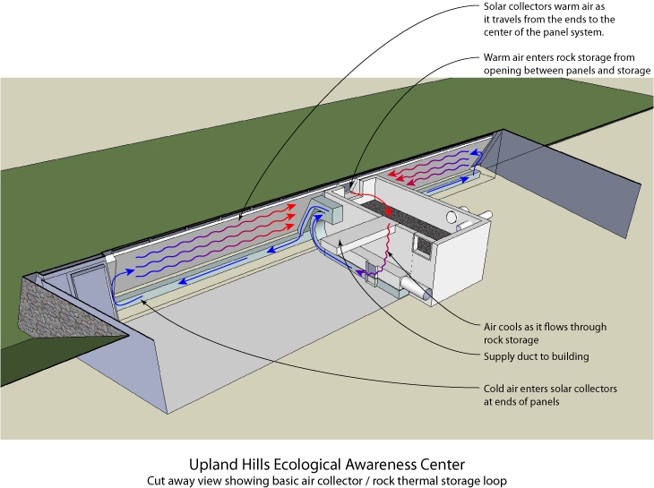
Diagram by Ryan Grabow
As our team examines the current condition of the rock storage bin, we notice that the system is no longer in proper working conditions. It is a dated system and appears to have had a lot of adjustments made in or around the design. Much of the ductwork is now unconnected within the system. The old furnace was taken out some time ago. When it was taken out the duct system was left disconnected, leaving large openings. There are also many random openings within the rock storage bin that need to be closed up before the proper operation can begin.
Installing Equipment

The Solar Thermal Heating Group installed 5 different systems within the parameters of our study area. A pyranometer was installed within the solar panel area. The pyranometer is a solar radiation light sensor that measures the average light intensity. It has a “measurement range of 0 to 128 W/m2 over a spectral range of 300 to 110 nm” (www.onsetcomp.com.) An air velocity sensor was installed behind the solar panel system. We also decreased the size of the opening between the inside of the rock storage bin and the panels. This may have caused a problem because the readings that the sensor recorded seem to be quite erratic. A suggestion would be to increase the opening in the hopes for a clearer reading from the sensors.
There are also three temperature sensors located within the building. There is one sensor located directly behind the solar panels to record the temperature of the air as it enters the rock storage bin. Another temperature sensor is located inside the rock storage bin. It is located within a pipe in the middle of the rock bin at approximately three feet into the rocks. This sensor will record the temperature inside the rocks. This will help us determine if the system is storing any heat and at what temperature it is being stored. The third temperature sensor is located in the interior of the building to record the interior temperature.
Also our team did an energy audit of the entire property of UHEAC. To do this we went through each room individually and recorded each device that may draw power. We then recorded all of the electrical properties. Next we interviewed Cliff Sholtz, since he would be the most knowledgeable source of the usage to date, on the usage of each device. I have included in the appendix the break down room by room of our energy audit
Recommendations

As of this date many of the recommendations for a more efficient working system can be seen. The duct system needs to be repaired and reconnected. There are some other holes in the rock storage bin that need to be covered. The flow of the air into the rock storage does not seem to work in the most logical way. The most efficient way for the system to store the heat would be to run the hot air in through the rocks or below the rocks. Naturally the hot air would raise thus excess air would be stored within the system. As of now the heat comes into the bin at the top surface of the rocks, therefore without the use of a fan, which would use power thus counteracting the energy saving system, the warm air escapes the bin through all of the loose openings.
Another situation that needs to be addressed is the open 8” dia. pipe at the west wall of the rock storage bin. We noticed that the opening opposite is the same diameter, however we do not know why this opening is here. Some thoughts are that this pipe could have been connected to the old furnace and used as an exhaust.
We did try numerous times to get the energy analysis software to work, with no luck. It seems the software is a bit tedious and needs more time dedicated towards learning the software then we first expected. I would suggest a group of people together learn the program so that each other could assist the others for possible faster energy simulations. The software we attempted to use was Energy Plus, this is a state of the art energy modeling software. This

software is free but difficult to use without interfaces. We also attempted ESP-r, EP Launch, EP-Quick, and Open Studio. We recommend IDF Editor, an Energy Plus utility, this is a new interface that came out this late November. We highly recommend Design Building because they say it is easy to use and work with Energy Plus, although the cost of Design Builder is significant (students get a 90% discount and educational universities get a 50% discount.)
Another benefit would be to have a devised schedule to follow that helps direct the investigation in a smoother manner. Preparation is the key. It was difficult to be prepared in this situation considering this is the initial and precedent examination. Some key tools are cable, tape measure, and basic tools (screwdrivers, ect.) I would suggest that at least one person per group should carry a basic tool bag.

References:
- Levy, M. Emanuel; Evans, Deane; Gardstein, Cynthia; Winter, Steven Associates Staff. The Passive Solar Construction Handbook: Featuring Hundreds of Construction Details & Notes, materials, Specifications, & Design Rules of Thumb, 1983.

- OnSite: A Smarter Environment Begins Here. Online. www.onsetcomp.com

- Garg, H.P.; Bandyopadhyay, B,; Sharma, V.K. “Investigation of rock bed solar collector cum storage system.” Energy Conversion and Management (1981); 21, 4, 275-282.

